Normalization Joseph Bolivar
Initial Document Format
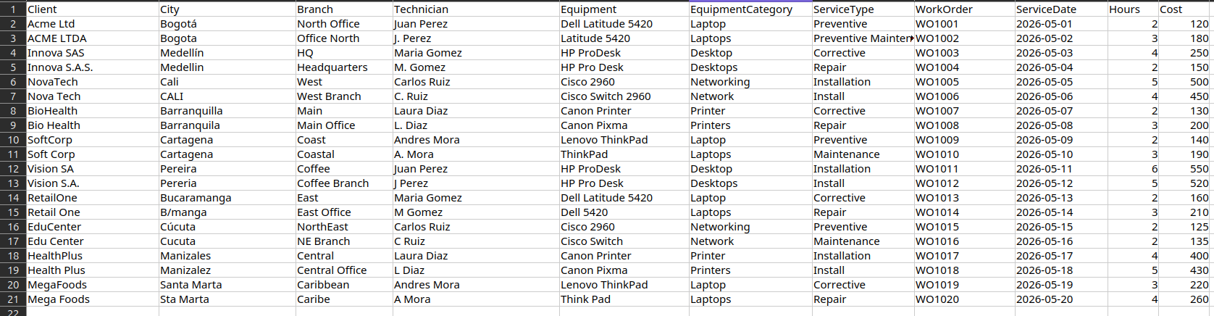
Problems Identified
First, I noticed inconsistencies in the "Customer" column, where several names were written differently or contained improper spacing, resulting in a poor visual presentation of the document.
In the "City" section, the same problem occurred. I normalized these names using proper capitalization, removing abbreviations, and adding accents where necessary.
In the "Branch" column, the issue was identical to the previous columns, with locations being incomplete or misspelled.
In the "Technician" column, some names were abbreviated. This shows a lack of professionalism, as it prevents properly tracking which technician performed the service.
In the "Equipment" column, some device names were missing parts, contained incorrect spacing, or were misspelled.
In the "Category" column, the names were misspelled or incomplete.
In the "Service Type" column, there were abbreviations that did not look professional. Considering the words used in this column, terms like "install" and "repair" were incorrect, and the word "maintenance" was missing according to standard engineering terminology.
The remaining tables do not require normalization as their data is already correct.

Database Fixes - Phase 1
In this phase, the previously mentioned inconsistencies were resolved in order to proceed to Phase 2 of data normalization. Names, spacing, terminology, classifications, and spelling issues were successfully corrected.

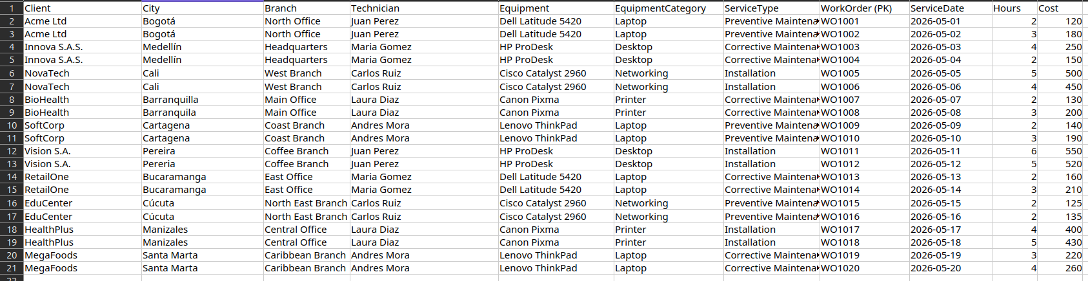
"Subsequently, I decomposed the dataset into 8 distinct tables, isolating each primary and foreign key to guarantee a well-structured relational database schema. The normalization transformations are detailed below:
Data pre-processing: All attributes were standardized prior to initiating the normalization process.
- 1NF (First Normal Form): Eliminated repeating groups; the primary key was structured around order_id (Dataset_normalizada).
- 2NF (Second Normal Form): Since the table relies solely on a single-attribute primary key (order_id), no partial dependencies exist. Therefore, the schema inherently satisfies 2NF requirements.
- 3NF (Third Normal Form): Removed all transitive dependencies by decoupling columns into specialized entity tables and mapping the respective foreign keys sequentially. [1, 2]
Dependency Resolution:
- Order-Client-Branch-City: Disconnected this chain because branch and city attributes depend functionally on the client, not on the order itself.
- Order-Equipment-Category: Removed this dependency since the category is functionally dependent on the equipment entity.
- Order-Technician-Service_Type: Dissolved this relationship by migrating entity names to their respective lookup tables.

Justification:
The architectural decision to establish city, branch, and category as independent entities was driven by business logic and the need to eliminate severe data redundancy across rows. In the client-branch-city hierarchy, city and branch data are strictly determined by the client ID. Keeping them within the order scope would introduce transitive dependencies, triggering data update anomalies.
Consequently, the order entity now strictly retains transactional metadata (date, time, cost) alongside the foreign keys, effectively mitigating data duplication.

